Using BAM in the Special Trips Agency

The latest release of the BPMS Special Agency Trips Agency BAM component showcases how to use persistence variable strategy to store process and task variables somewhere else (using H2 in-memory database) and not as part of process instance.

This document provides a step-by-step guide on how to get variables stored and the resulting tables queried for data in a JBoss BPMS Business Dashboard.

Phase 1: Persisting Data Variables

Step 1 – adding annotation
There are 6 variables we want to persist out of the seven in the application:
Variable | Definition | Persisted
Applicant | Dimension table with identifying details e.g. name, email | Yes
BookingObject | Main fact table holding data for an entire trip | Yes
Flight | Details about the flights | Yes
Hotel | Details about the hotel | Yes
PaymentDetails | Credit card details and payments | Yes
Rejection | Used by the rules engine | No
TravelDetails | Details about the route and travelling party | Yes

For each class that is being persisted, an @Entity and an @Id annotations were added... as in the Applicant class example presented below:

@Entity
public class Applicant extends java.lang.Object implements java.io.Serializable {
static final long serialVersionUID = 1L;

@Id
@GeneratedValue( strategy=GenerationType.AUTO )
private Integer appId;

Please note, the ID type should not be object instead of a primitive (e.g. Integer instead of int).

Step 2 – adding helper classes
There are two more classes that needed to be added to the project
- one for marshalling strategy, and
- one for classloading on read/write operation for variables.

The following articles gives an extensive overview on why this is necessary: http://mswiderski.blogspot.co.uk/2014/02/jbpm-6-store-your-process-variables.html

Step 3 – Telling the BPM engine about persistence
The next step is to inform the process engine about the desire to persist our variables. This is achieved using two files:

a) persistence.xml file
This file informs the server which database is supported to save/update/query entity objects. The file is stored in the META-INF directory inside the JAR file that contains the entity beans. For the Special Trips Agency, the persistence.xml file looks as follows:

<?xml version="1.0" encoding="UTF-8"?>
<persistence
version="2.0"
xmlns="http://java.sun.com/xml/ns/persistence"
xmlns:xsi="http://www.w3.org/2001/XMLSchema-instance"
xsi:schemaLocation="http://java.sun.com/xml/ns/persistence http://java.sun.com/xml/ns/persistence/persistence_2_0.xsd">

<persistence-unit name="org.jbpm.custom" transaction-type="JTA">
<provider>org.hibernate.ejb.HibernatePersistence</provider>
<jta-data-source>java:jboss/datasources/ExampleDS</jta-data-source>

<class>org.specialtripsagency.BookingObject</class>
<class>org.specialtripsagency.Applicant</class>
<class>org.specialtripsagency.Flight</class>
<class>org.specialtripsagency.Hotel</class>
<class>org.specialtripsagency.PaymentDetails</class>
<class>org.specialtripsagency.TravelDetails</class>

<properties>
<property name="hibernate.dialect" value="org.hibernate.dialect.H2Dialect" />

<property name="hibernate.max_fetch_depth" value="3" />
<property name="hibernate.hbm2ddl.auto" value="update" />
<property name="hibernate.show_sql" value="false" />

<!-- BZ 841786: AS7/EAP 6/Hib 4 uses new (sequence) generators which seem to cause problems -->
<property name="hibernate.id.new_generator_mappings" value="false" />
<property name="hibernate.transaction.jta.platform" value="org.hibernate.service.jta.platform.internal.JBossAppServerJtaPlatform" />
</properties>
</persistence-unit>
</persistence>

b) kie-deployment-descriptor.xml file
This file informs the server which marshalling strategy to use with the entity objects. The file is stored in the META-INF directory inside the JAR file that contains the entity beans. For the Special Trips Agency, the kie-deployment-descriptor.xml file looks as follows:

<?xml version="1.0" encoding="UTF-8" standalone="yes"?>
<deployment-descriptor xsi:schemaLocation="http://www.jboss.org/jbpm deployment-descriptor.xsd" xmlns:xsi="http://www.w3.org/2001/XMLSchema-instance">
<persistence-unit>org.jbpm.domain</persistence-unit>
<audit-persistence-unit>org.jbpm.domain</audit-persistence-unit>
<audit-mode>JPA</audit-mode>
<persistence-mode>JPA</persistence-mode>
<runtime-strategy>SINGLETON</runtime-strategy>
<marshalling-strategies>
<marshalling-strategy>
<resolver>mvel</resolver>
<identifier>new org.specialtripsagency.util.ProjectJPAResolverStrategy(classLoader)</identifier>
<parameters/>
</marshalling-strategy>
</marshalling-strategies>
<event-listeners/>
<task-event-listeners/>
<globals/>
<work-item-handlers>
<work-item-handler>
<resolver>mvel</resolver>
<identifier>new org.jbpm.process.workitem.webservice.WebServiceWorkItemHandler(ksession, classLoader)</identifier>
<parameters/>
<name>WebService</name>
</work-item-handler>
<work-item-handler>
<resolver>mvel</resolver>
<identifier>new org.jbpm.process.instance.impl.demo.SystemOutWorkItemHandler()</identifier>
<parameters/>
<name>Log</name>
</work-item-handler>
<work-item-handler>
<resolver>mvel</resolver>
<identifier>new org.jbpm.process.workitem.bpmn2.ServiceTaskHandler(ksession, classLoader)</identifier>
<parameters/>
<name>Service Task</name>
</work-item-handler>
<work-item-handler>
<resolver>mvel</resolver>
<identifier>new org.jbpm.process.workitem.rest.RESTWorkItemHandler()</identifier>
<parameters/>
<name>Rest</name>
</work-item-handler>
</work-item-handlers>
<environment-entries/>
<configurations/>
<required-roles/>
<remoteable-classes/>
</deployment-descriptor>

Step 4 – uploading changes
Once these changes have been made to the variables, all the changes are uploaded to the BPM engine. Before the upload, a small change needs to be made to the main specialtripsagency process. In the BookingObject variable, there is a field called BookingId that is populated in the Prepare Data script task.
Go to the script task and locate the kcontext entry populating BookingId. (Note, it should be populated by a static value of 12345. Change it so that it is populated by the processID value. (please note, these changes may have already been implemented – if so, the value should be _processId).

The .niogit files ($JBOSS_HOME/bin/.niogit/{specialtripsagency.git | system.git} are added to the support folder and a git pull request is made.

Phase 2 – JBoss BPM Business Dashboard

This paper does not discuss how to build business dashboards. Those instructions can be found here: http://docs.jboss.org/dashbuilder/release/6.2.0.Final/html/chap-dashbuilder-first_steps.html Instead, this paper provides instructions on how to run the pre-built dashboard in order to view data coming from persisted business variables.

In order to carry out the following steps. Ensure that
- the BPM server is up and running
- Some data has been generated by starting a few instances or running the instance-generator project

Step 5 – Configure an external datasource for BAM
In Business Central, navigate to the Dashboard tab and select the Business Dashboards link as shown in the image below:
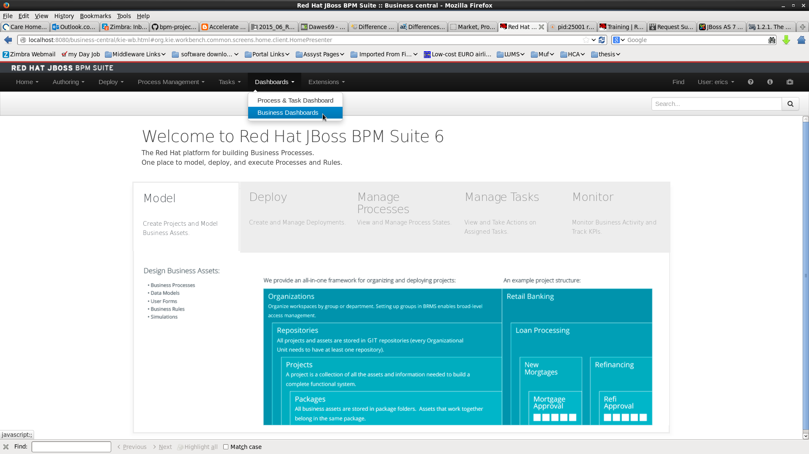
On the resulting page, navigate to the Administration section as shown in image below
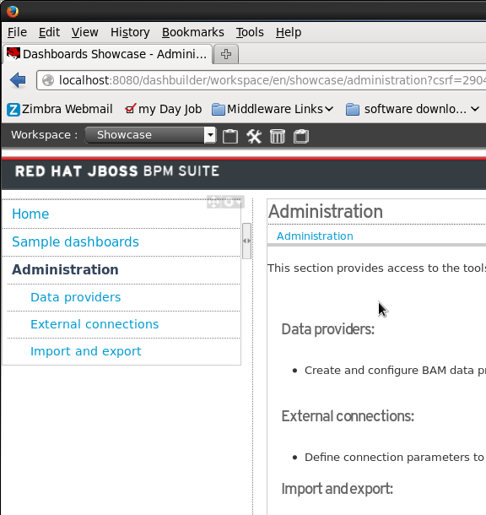
Click on “External Connections” and click on “Create a new DataSource” so that the resulting screen looks as follows:

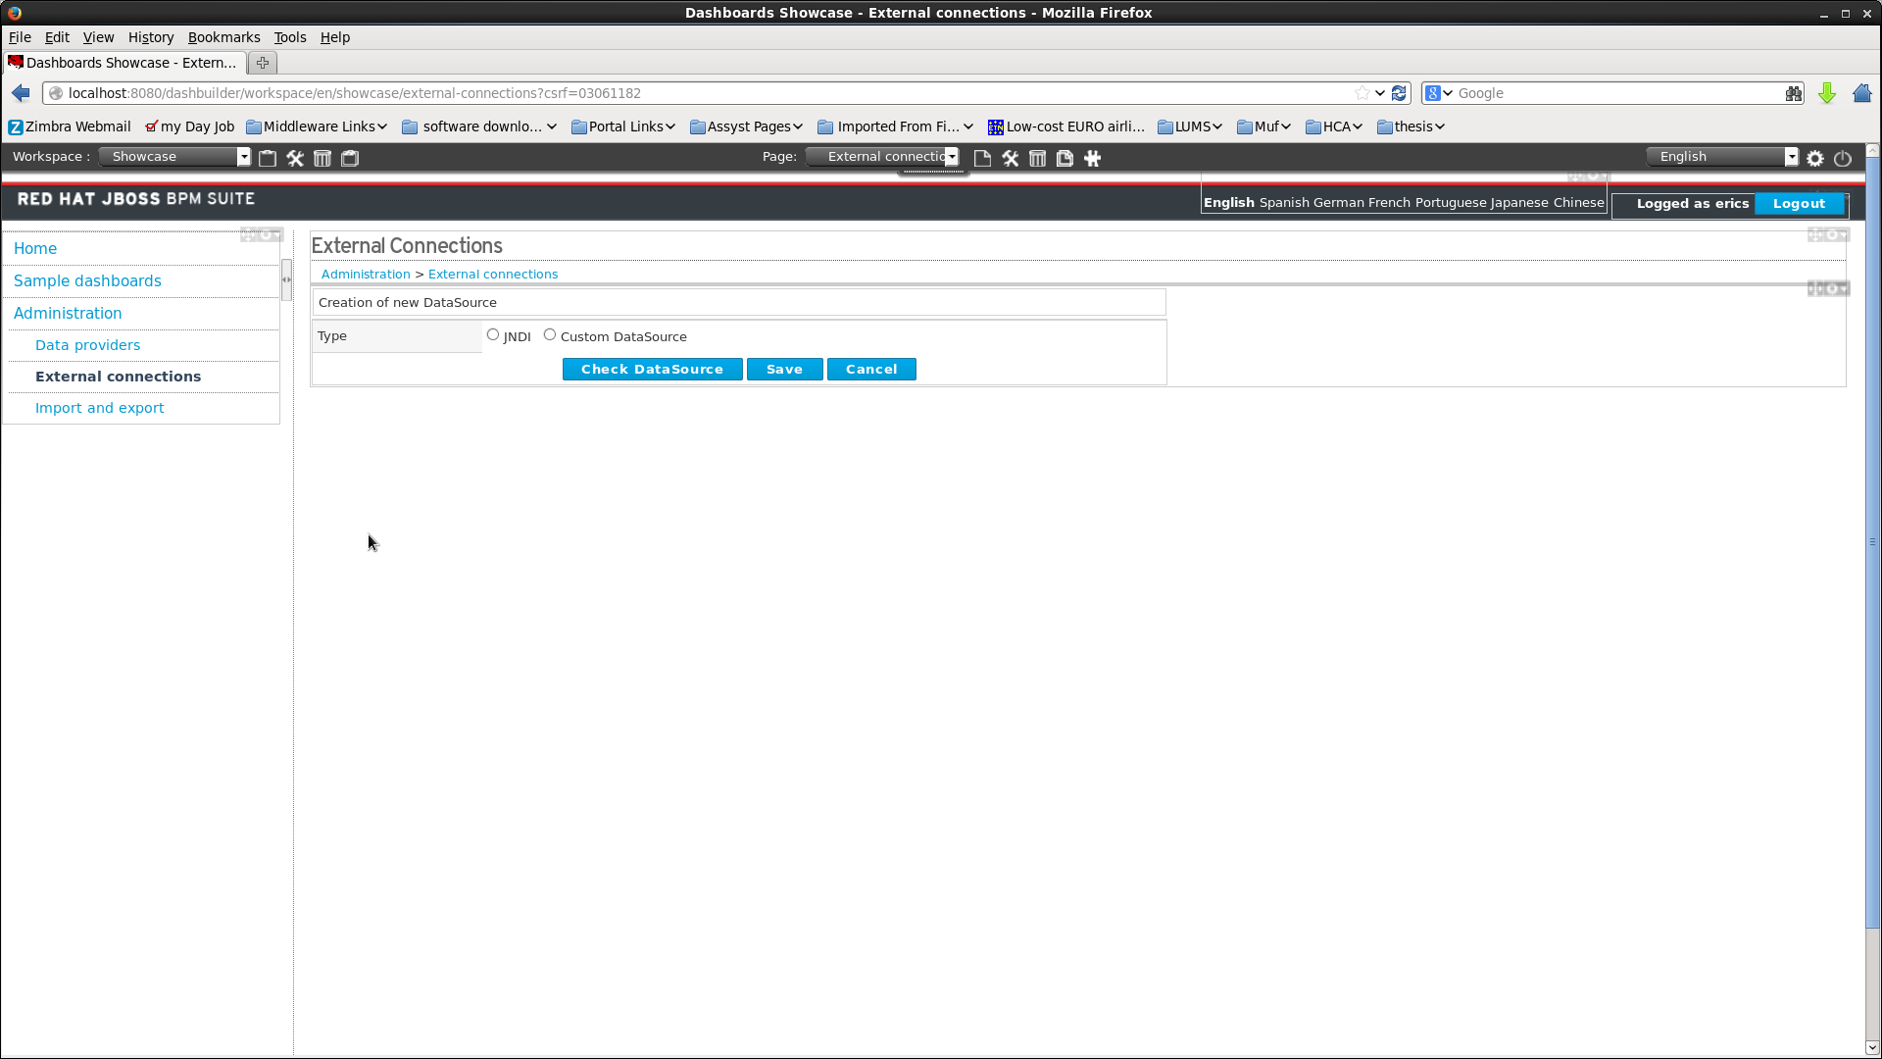
You can choose to create a JNDI or a Custom DataSource. In this paper, we are creating our data source from JNDI. Click on that Type and enter the following details
type=JNDI
name=DashboardDS
testQuery=SELECT 1
jndiPath=java:jboss/datasources/ExampleDS

Click on “Check DataSource” to test, then “Save” to store the change.

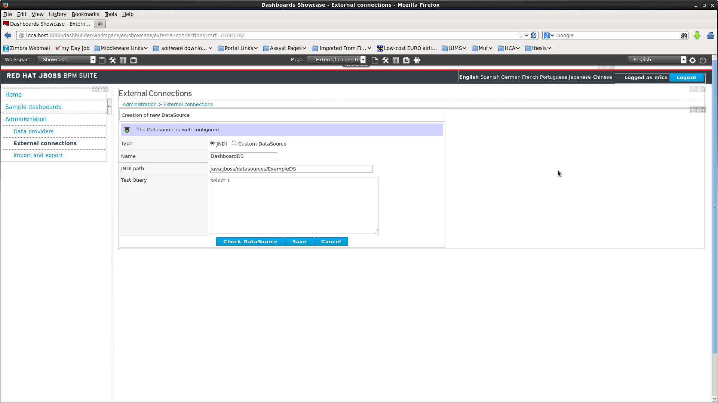
Configuring the data source is now complete.

Step 6 – Import data providers
As mentioned, please make sure there is some data in the database (i.e. start a few instances before doing this step).

The next stage is to import KPIs and data providers into the server.
Click on Administration >> Import & Export >> Import Dashboard Tab. The following page should display:

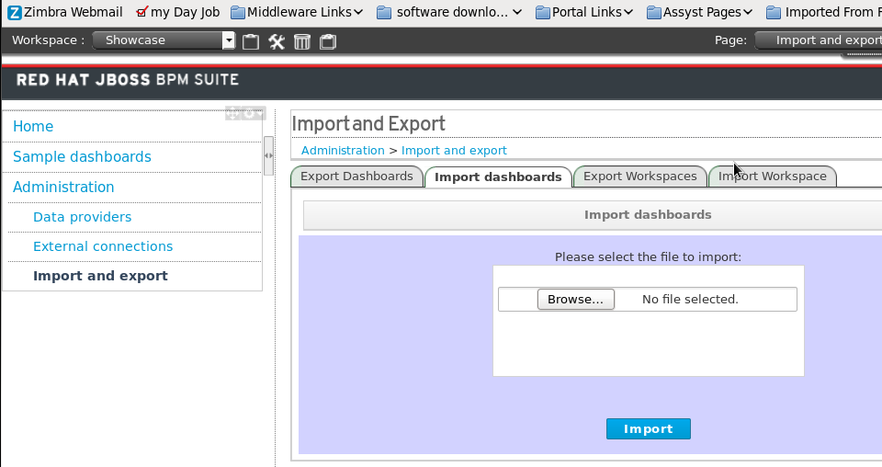
Click on Browse and navigate to the Support/BAM Files folder and choose the file: kpiExport_1609002583.kpis. Follow the wizard steps that follow and import the file.

Adding data sources is now complete.

Step 7 – Import the Travel Agency workspace.
The final step is to import the workspace widgets that display data related to the special trips project. To import the workspace do the following:
Click on Administration >> Import & Export >> Import Workspace tab.

Click on browse and navigate to the Support/BAM Files folder and choose the file: export.workspace. Follow the wizard steps that follow and import the file.

Adding the workspace is now complete.

You now have a business dashboard getting data from externally persisted variables.

